**DSO TRAINING AND UPSKILLING**

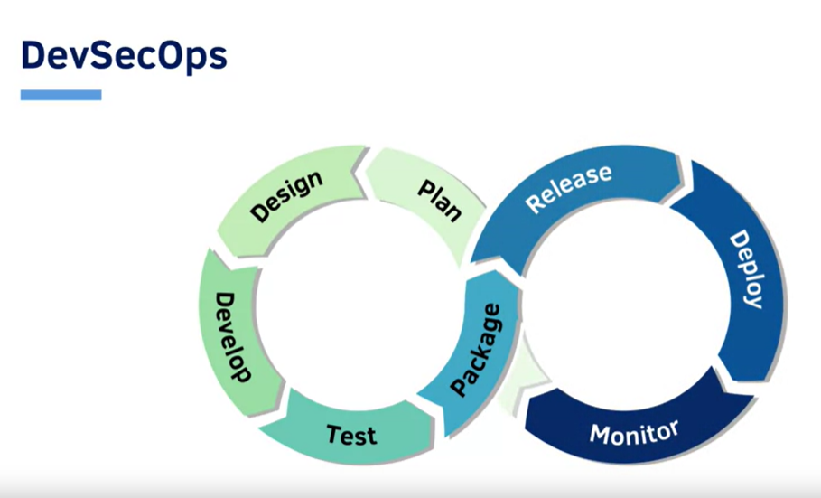

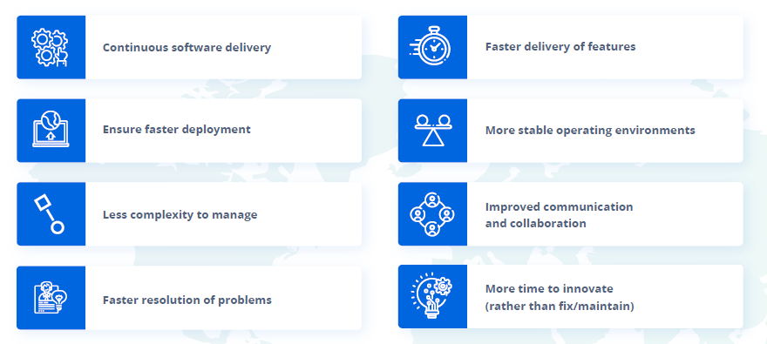

**AGENDA**

* **DevSecOps Fundamentals:**

Software Development and DevSecOps, DevSecOps Lifecycle and Tools, DSO on cloud & Linux.

* **Source Code Management using GIT**
* **Continuous integration using TFS GIT:**

**Important concepts:**

* Creation of azure-pipelines.yml file
* adding relevant task from the scheduler assistant.
* Assign branch name in trigger
* PublishBuildArtifacts task is required to publish our artifact (final ear of our application) to Azure container.
* Running the pipeline
* ANALYSING THE PIPELINE with different jobs.
* **Continuous Deployment using Docker:**

Image Management and Registry, Storage in Docker, Container Orchestration using Docker & Networking and Security.

* **Container Orchestration using Kubernetes**

Container Orchestration, K8s Services and Scheduling, K8s Controllers, Storage, Securing and Troubleshooting the cluster.

* **Continuous Monitoring and DSO on AWS**

Continuous Monitoring using Prometheus & Nagios XI, Automation infrastructure using CloudFormation Elastic Beanstalk, ECS and EKS & OpsWorks.

* **Static application security testing (SAST),** or static analysis, is a testing methodology that analyzes source code to find security vulnerabilities that make your organization’s applications susceptible to attack. **Example**: Coverity and SonarQube integration.
* **Dynamic Application Security Testing (DAST)** is the process of analyzing a web application through the front-end to find vulnerabilities through simulated attacks.
* **Software composition analysis (SCA)** The goal of SCA is to detect embedded open-source software and determine if they are up-to-date, contain security flaws, or have licensing requirements.
* How to integrate Coverity setup in development pipeline.

**COURSES AND TRAINING**

* **Docker and K8s - Author Nigel Poulton video course on Pluralsight.**

[https://nigelpoulton.com/video-courses/](%20https://nigelpoulton.com/video-courses/)

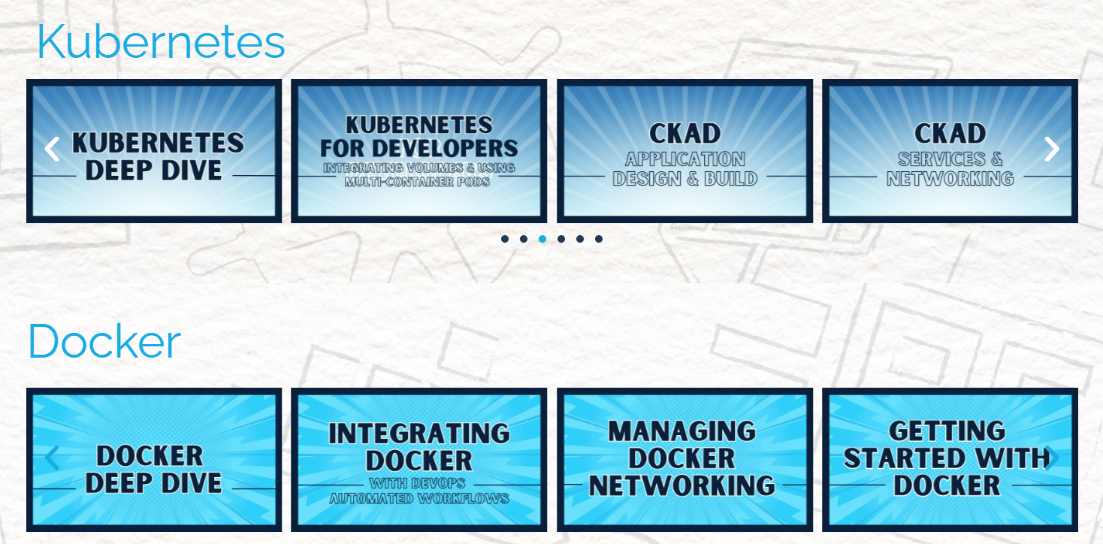

Help needed – Need pluralsight license for atleast DSO core team.

* <https://www.coursera.org/learn/introduction-to-devsecops>
* **Certifications**

DevSecOps Foundation

<https://www.devopsinstitute.com/certifications/devsecops-foundation/>

* **DevSecOps Practitioner**

<https://www.devopsinstitute.com/certifications/devsecops-practitioner/>

* **Training and Certificate Course**

DevSecOps for Software Engineers and Architects Boeing Certificate(Learning Path)

<https://workforcecenter.slu.edu/public/category/courseCategoryCertificateProfile.do?method=load&certificateId=1337114>